6A^{th} Grade: Unit 4, Lesson 1

- What direction does the x-axis run on the coordinate plane?

Horizontal (left to right)

- What is the distance between points R and M on the number line?

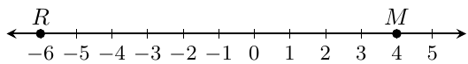

10

- Which axis on the coordinate plane runs vertically?

The y-axis

